**The Story of Two Cats and a Rabbit**

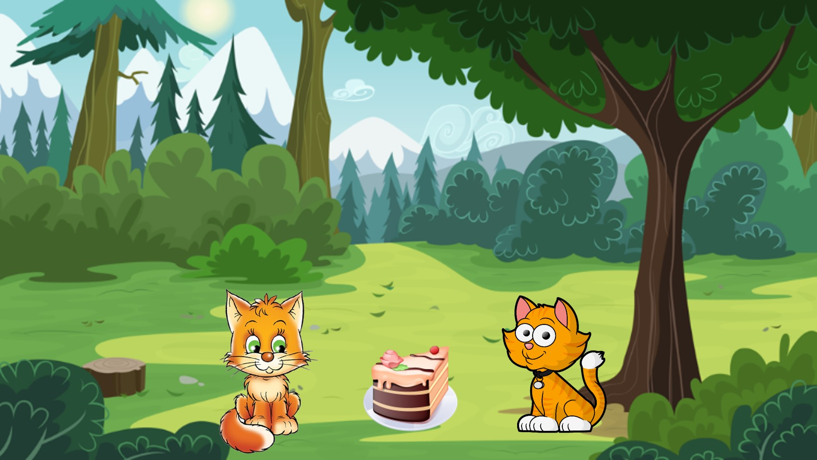

Two cats were prowling together in the jungle. One of the cats saw a big cake and missed. The other jumped up and picked it.

The first cat said “Give me the cake. It is I who saw it first.”

The other cat said “Keep away from it. It is I who picked it up.”

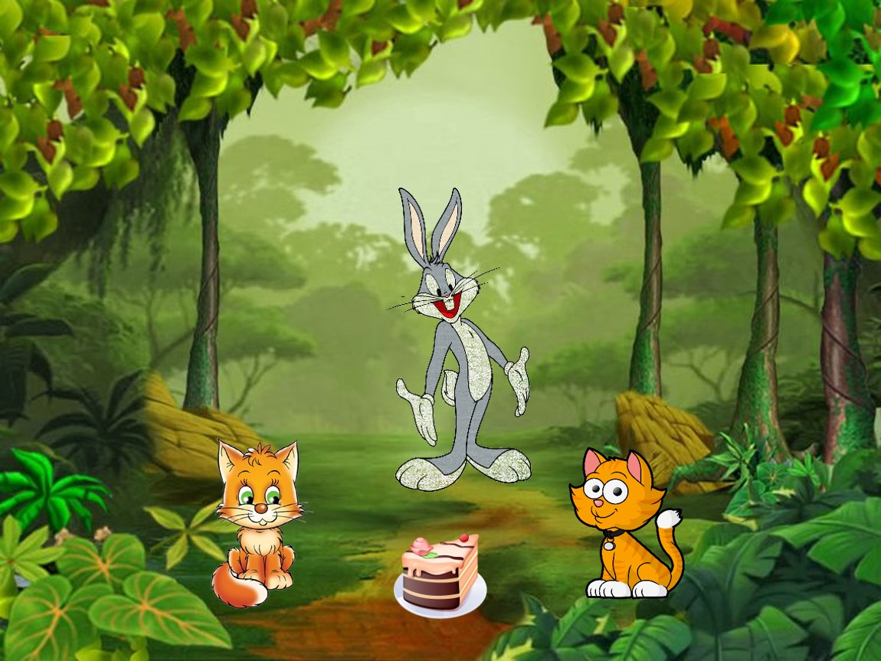

They were fighting and fighting. But there was no solution. Just then, a rabbit passed by.

Rabbit thought “What foolish cats they must be! Let me make use of this chance.”

Rabbit came to the cats and said in a loud voice. “Don’t fight. Let me split the cake for you ”. The cake was handed over to the rabbit.

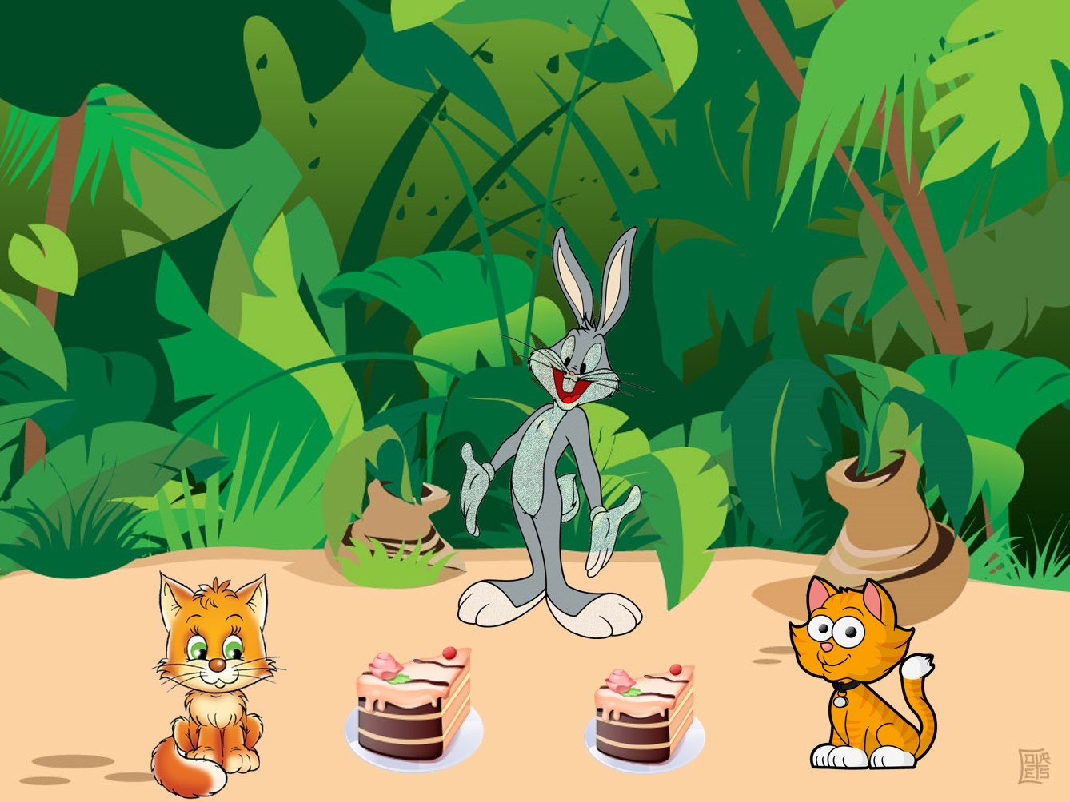

The rabbit split the cake into two parts.

He shook his head and said, “Ohh no! One is bigger. One is smaller. Now I will have to eat a part of bigger slice, so you both get equal size of cake.”

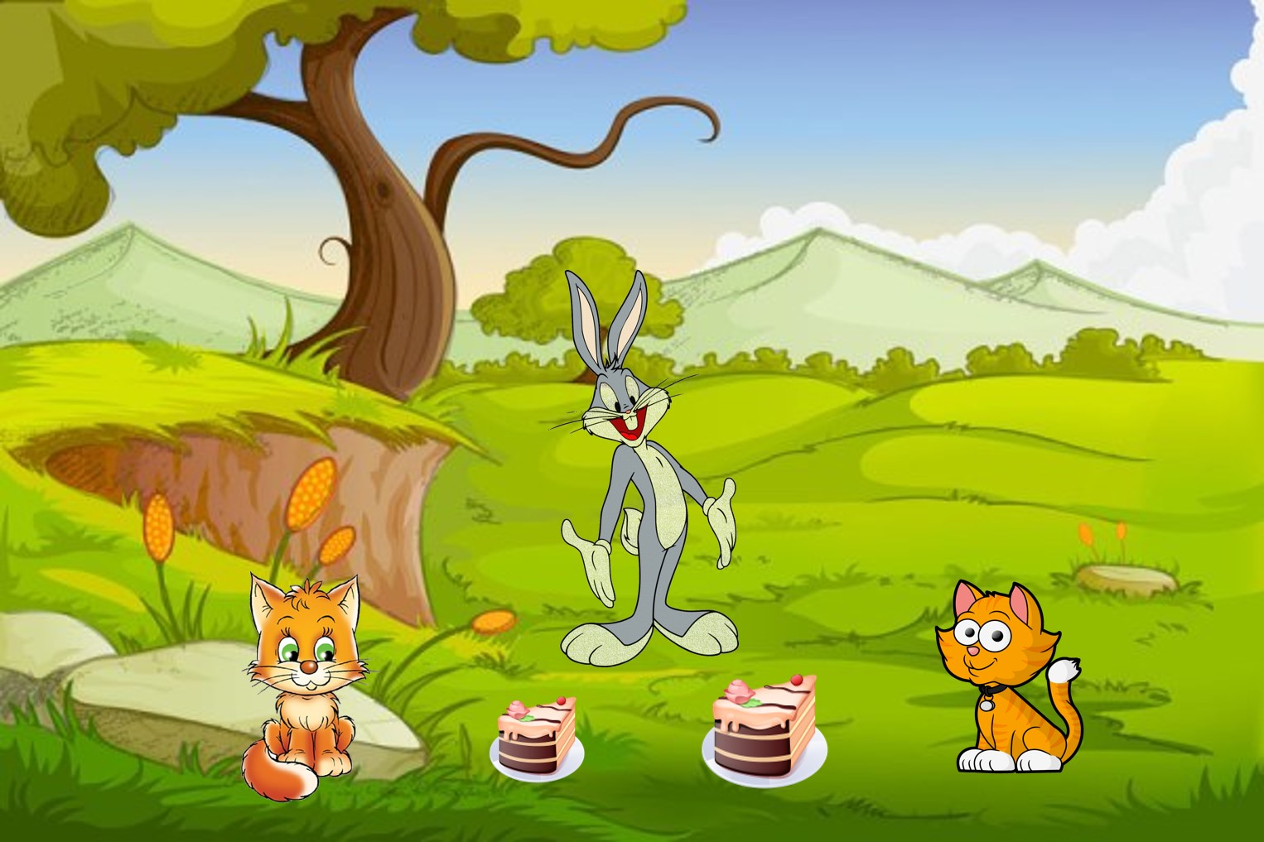

After biting of the bigger slice, he said “Oh no! Now this has become smaller now”.

So the rabbit to a bite from second slice of cake. And thus, he went on eating from part to part and finally finished the whole cake.

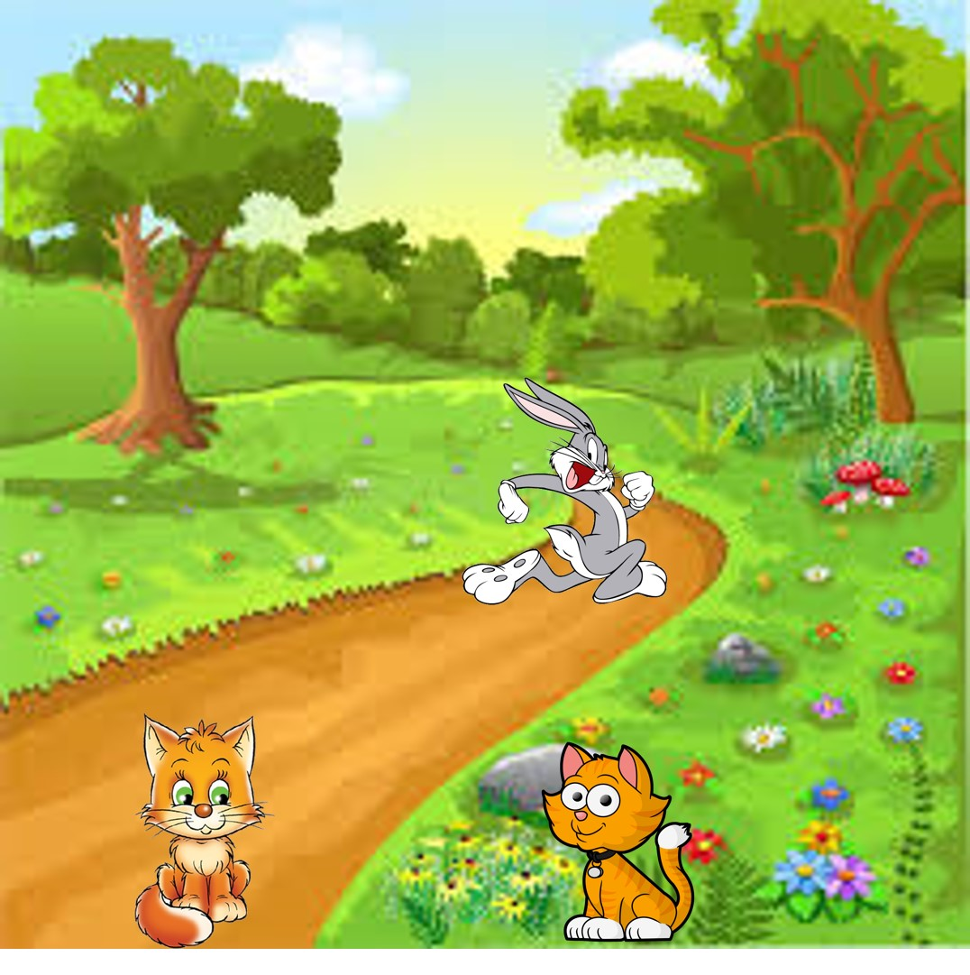

After the cake was finished, the rabbit laughed and ran away. The cats became very sad and started crying due to their foolishness.

Moral of the Story:

When you quarrel over something, someone else gains from it.